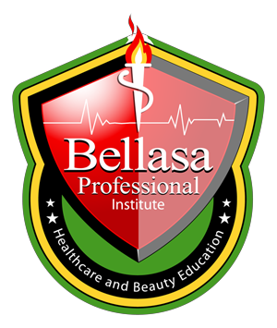
CATALOG

BELLASA PROFESSIONAL INSTITUTE
A Unique Career,
For a Unique You,,.
2023-2024

700 S Royal Poinciana Blvd

Suite 103, 303

Miami Spring, FL 33166

Phone (786) 631-5676
Fax (786) 513-3330
info@bellasa.edu

Volume 15 Effective 09/19/2023

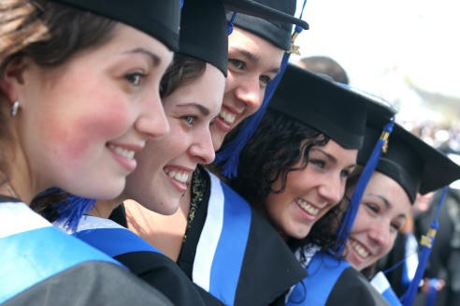

BEAUTY AND HEALTH EDUCATION

Bellasa Professional Institute License # 3367

- Cosmetology
- Electrology
- Facial Specialist
- Full Specialist
- Nail Technology
- Medical Aesthetician Program

Mission & Vision Statement 3
Licensure/ Accreditations 3
Administrative Staff and Faculty 3
History 4
Facilities 4
Handicap Facilities 4
Statement of Legal Control 4
ADMISSION
Admissions Requirements 4
Application Procedure 4
Enrollment 4
Payment of Tuition 4
Course Numbering System 4
Definition of Clock Hour 4
Disclosure Statement 4
Credit For Previous Experience or Training/transfer of credits between programs within the institution/change of program 5
GENERAL INFORMATION
Rules and Regulations 6
Academic Calendar 6
Holidays 6
Hours of Operation 6
Library Resources 6
Family Educational Rights and Privacy Act (FERPA) 6
Complaints and Grievance Procedure 7
Student Housing 7
Dress Code 7
Transfer of Credit Earned 7
Student Placement 7
ACADEMIC INFORMATION.
Leave of Absence 8
Academic Grading System…………………………………………………………………………....8
Attendance /Tardiness .8
Withdrawal / Readmission .8
Satisfactory Academic Progress .9
Graduation Requirements 10
Academic Advising/Tutoring 10
Media Center 10
Cancellation and Refund Policy 10
Transcripts and Diplomas 10
Office of Financial Aiid.........................................................................11
FASFA ..............................................................................................12
PROGRAMS
Cosmetology.....................................................................................13-14
Electrology........................................................................................15-16
Facial Specialist.................................................................................17-18
Full Specialist………………………………………………………………………………………………….19-20
Nail Technology………………………………………………………………………………………………21-22
Medical Aesthetician Program ……………………………………………………………………….23-24

CATALOG—BELLASA PROFESSIONAL INSTITUTE
2

STAFF

Administrative

MISSION STATEMENT
Our mission is to develop highly skilled students who will be successful in demanding technical fields.

VISION STATEMENT
To be recognized as an Institution that prepares highly qualified students for immediate employment in technical occupations.

LICENSURE
Licensed by the Commission for Independent Education, Florida Department of Education.
License #3367.
Additional information regarding this institution may be obtained by Contacting the Commission at:
325 West Gaines Street, Suite 1414
Tallahassee, Florida 32399-0400
toll free telephone number (888)224-6684. www.fldoe.org

ACCREDITATION

Bellasa Professional Institute is ap- proved by the Commission of the Council on Occupational Education.

Additional information regarding this institution may be obtained by Contacting the Commission at:

7840 Roswell Road, Building 300, Suite 325
Atlanta, GA 30350

Telephone (Local): 770-396-3898
President & School Director, Robert Babani Director of Education, Evahmaria Babani
Admission Services, Olga Babani
Placement Services, Evahmaria Babani
Financial Services, Esther Babani

Faculty
Beatriz Fayas

Facial Specialist Instructor Facial Specialist—FS9759019
Ses derma USA Skin Care (Diploma), Doral, FL
Kevin Reilley, CME
Electrology Instructor
Electrologist— Lic # EO 738
Hollywood Institute (Diploma), Hollywood, FL
Ana Morales
Cosmetology Instructor
Cosmetology Lic # CL1286561 Mannellos school of Beauty 2009
Rosa Torres
Facial Specialist /Nail Instructor
Full Specialist Lic # FS 908607
Bellasa Professional Institute, North Miami, FL

CATALOG — BELLASA PROFESSIONAL INSTITUTE 3

HISTORY
Bellasa Professional Institute was established in November 2011 as an educational center offering programs in healthcare and beauty education.

FACILITIES
Bellasa Professional Institute Main is located at 744 NE 125th Street, Miami Florida 33161. This location is easily accessible to major highways and location consists of 3000 square feet of classroom and practical areas with real-world equipment and a resource area.
The school is conditioned with equipment for student learning and practice. The modern facilities classrooms, clinical and treatment rooms allow the most up to date teaching methods. The school is proud of its small and specialized classes where students receive personalized instruction.

HANDICAP FACILITIES
Bellasa Professional Institute License # 3367 complies with all provisions of section 504 of the Rehabilitation Act of 1973 in that no qualified handicapped person will be excluded from enrolling in the school. However, handicapped individuals should be aware that the regulations set by the State of Florida require a high level of manual dexterity and prolonged periods of practical work in the clinic.

STATEMENT OF LEGAL CONTROL
Bellasa Professional Institute is a DBA of Laserdermadspa Inc. owned by Robert Babani. The director of the corporation is Robert Babani. The corporation address is 700 South Royal Poinciana Blvd Suite 103/303, Miami Springs, FL 33166.

ADMISSIONS

ADMISSIONS REQUIREMENTS
Present a high school diploma, GED, or pass an Ability to Benefit (ATB) entrance test.
ATB entrance test requirements: Pass the Wonderlic Ability to Benefit Test with a minimum passing score of 200 for the Verbal portion, and 210 for the Quantitative portion of the exam.
Admissions Note: students enrolling with an ATB entrance test (instead of a High School Diploma or GED) are not eligible to apply for Federal Financial Aid.
Any person under the age of 18 will be required to have parental approval. No students currently attending high school will be accepted. No person shall be excluded from participation or be subject to any form of discrimination because of race, color, sex, ethnic origin, religion, age, or disability.

Evaluation of the validity of High School Diploma
Regulation 34 CFR 668.16 (p) requires Title IV schools to establish policies and procedures
to confirm the authenticity of high school diplomas in the event that the school or the
Secretary of the U.S. Department of Education has reason to question the validity of a
student’s high school diploma. The school may require further documentation in the form
of a certified copy of final high school transcripts for the high school in question or information
from a company that evaluates foreign diplomas (in the case of a foreign diploma) and translate them into English. Bellasa Professional Institute will then confirm that the student is eligible for Postsecondary instruction. Student self-certification is not considered sufficient proof of validity. In addition to checking online for further information about the school issuing the diploma and its accreditation, the school may also contact the Department of Education in the state in which the diploma was issued to determine if the school listed on the diploma is on the state list of recognized schools.
The school maintains a list of known diploma mills for the admissions staff to check when
receiving a diploma from an unknown and questionable source. It is understood that this list may not be all inclusive as there are hundreds of diploma mills some known, and some not currently known. It is also understood that the list of schools in the FAFSA drop down box online does not guarantee that a high school is legitimate. The school makes every reasonable effort to verify the validity of questionable high school diplomas.

APPLICATION PROCEDURE
Applicants are required to visit the school in person to meet with an admissions representative. The admissions representative will discuss career goals, programs, and provide a tour of the school for each applicant. The prospective student must complete an application for enrollment.

ENROLLMENT
Prospective students must make a formal application to and be accepted by the school, as well as complete and sign an Enrollment Agreement prior to beginning classes. Applicants are encouraged to complete the enrollment process well in advance of their desired start date, as class size is limited to ensure individualized instruction.

PAYMENT OF TUITION
Payment of tuition is due in full, on or before the first day of class. Any students who are unable to pay the tuition and fees in full may arrange a payment plan to be paid weekly to the school. Contracts are not sold to third parties; however, the school reserves the right to assign any unpaid balances to an outside agency for collections.

COURSE NUMBERING SYSTEM
The course numbering system uses a 5-6 digital alpha-numeric identifier. The prefixes represent the subject area. The suffixes are numbers that represent the sequence taught. The prefixes are as follows:

COS - Cosmetology NAIL - Nail Technology
ELE – Electrology HIV - HIV/AIDS
FS- Facial Specialist
FSP -Full Facial Specialist
ELE – Medical Aesthetician Program (Electrology and Skin Care)

DEFINITION OF CLOCK HOUR
Students are awarded clock hours for course completion. A clock hour is defined as a minimum of 50 minutes of supervised or directed instruction and appropriate breaks.

DISCLOSURE STATEMENT
Students enrolled in the Electrology program, Cosmetology, Facial Specialist, Nail Technology programs may be required to disclose criminal history when applying for licensure.

CATALOG — BELLASA PROFESSIONAL INSTITUTE 4

CREDIT FOR PREVIOUS TRAINING
Credit may be granted for training in another school. Documentary proof verifying completed hours for comparable curse must be submitted prior to
enrollment. Written practical tests will be given to the applicant provided they are properly registered at the school. The director will then administer the
tests and determine what credit should be given. A maximum of 75% of previous credit will be awarded or transferred to the school.

TRANSFER OF CREDITS BETWEEN PROGRAMS WITHIN THE INSTITUTION

Bellasa Professional Institute offers transfer of credits between programs within the institution. Students enrolling in a new program will receive at time of enrollment applicable credits from previous programs completed at the institution.

CATALOG — BELLASA PROFESSIONAL INSTITUTE 5
GENERAL
INFORMATION

RULES AND REGULATIONS

The students are expected to conduct themselves in a manner that will reflect the integrity and professionalism of the school. Therefore, the following rules and regulations must be adhered to by all students. Any breach will subject the student to possible suspension for a period determined by the school director. The school reserves the right to terminate a student whose personal conduct is deemed unsatisfactory.
- Come to school as if you are going to work well-groomed, conservative hairstyle, clean nails, etc. Wear a white lab coat or jacket when working on clients.
- Daily attendance is required. Any excused absences must be made up, and all absences must be reported to the office by 9:30 am the day of the absence.
- Tuition payments are due in the office every Monday (or Tuesday for night students).
- All students are required to always work in a professional manner.
- All rules of Sanitation and Sterilization are to be followed. Students are responsible for their workstation, including the proper draping and preparation of all surfaces, chairs and tables used upon service completion. All supplies used must be replaced immediately. Waste baskets must be emptied at the end of each day.
- No food, drinks, or smoking is allowed during class or in the work area at any time.

CATALOG — BELLASA PROFESSIONAL INSTITUTE 6

ACADEMIC CALENDAR

The school operates on a continuous basis, 12 months per year. New classes begin weekly.

HOLIDAYS
The school observes the following Holidays and will be closed on those dates:
New Year’s Day
Martin Luther King, Jr. Day (for students only) Memorial Day
Juneteenth
Independence Day Labor Day
Veteran Day
Thanksgiving Weekend Christmas Day
The school Director may declare additional Holidays. Will be announced at such time.

HOURS OF OPERATION
Bellasa Professional Institute offers day and evening classes. Day classes are scheduled from 9:30 a.m. to 3:30 p.m., Monday through Thursday. Evening classes are scheduled from 6:00 p.m. to 10:00 p.m., Monday through Thursday.

LIBRARY RESOURCES
The schoolhouses additional learning resources for students in the front office. Resources include texts, videos, dictionary, thesaurus, and program appropriate periodicals. The library is open during normal business hours as noted above.

FAMILY EDUCATIONAL RIGHTS AND PRIVACY ACT (FERPA)
Bellasa Professional Institute strictly adheres to the requirements of FERPA regarding students’ rights and privacy of information. In accordance with public law 93-380, Family Educational Rights and Privacy Act, Florida Statute 5.229.782, the school allows students to access their educational records; challenge records they believe are inaccurate, incomplete, or misleading; and limit the release of such information. Records will not be released without the written consent of the student. A student will be notified whenever a court subpoenas the records in which case, written consent is not required. The parent (s) of a dependent student has the right to inspect records that are maintained by the school on behalf of the student.

COMPLAINTS AND GRIEVANCE PROCEDURE

Bellasa Professional Institute is dedicated to the success and well-being of each student, staff
members, and teacher. If dis-
satisfaction arises, interested parties are expected to refer their complaints to a school administrator or school president, in writing, to be resolved. A school representative will meet with the complainant within 10 days of receipt of the written complaint and provide a written final resolution.
Should a complaint not be handled in a Satisfactory manner, any student, staff member, or
teacher may contact:

Commission for Independent Education
of the Florida Department of Education
325 West Gaines Street, Suite 1414
Tallahassee, FL 32399
Toll free phone 888-224-6684 or www.fldoe.org/policy/cie/file-a-complaint
or/and contact:

Commission of the Council on Occupational Education
7840 Roswell Road, Building 300 Suite 325 Atlanta, GA 30350 Telephone (Local): 770-396-3898 Telephone (Toll-Free): 800-917-2081 Fax: 770-396-3790 http://www.council.org/
US Department of Education complaints can be filed electronically via the Feedback Center at: https://studentaid.gov/feedback-center/.

STUDENT HOUSING

Bellasa Professional Institute does not offer on- site housing for its students. There are many hotels, motels, and apartments conveniently
located near the school. Our office maintains a list of available locations that may be suitable for out-of-town students. We will gladly assist you in locating a place to stay while attending our school.

DRESS CODE
Students are required to wear scrubs, with a cost of approximately $60. All stu- dents are treated equally and are required to practice good hygiene as a daily routine. A clean, professional appearance is essential in school. Because of the nature of our work, it is important to maintain a sterile environment.

TRANSFER OF CREDIT EARNED
The school cannot guarantee transferability of credits earned to any other educational institution. Any decision on the acceptance of credits earned at Bellasa Professional Institute is at the sole discretion of the receiving institution. It is the student’s responsibility to confirm whether credits will be accepted by another institution of the student’s choice.

STUDENT PLACEMENT
The Placement Office assists students in finding available positions. Graduates are encouraged to utilize the services of the Placement Office.
The school cannot guarantee employment for its graduates. However, due to the school’s high standards and the individual attention given to each student, our graduates are well qualified.

CATALOG — BELLASA PROFESSIONAL INSTITUTE 7

ACADEMIC INFORMATION

LEAVE OF ABSENCE
Students who need to take a leave of absence from the school must submit, in writing, a signed request. Students on a leave of absence are not considered to be withdrawn from school. Students can only be granted one leave of absence per 12-month period, and the leave cannot exceed 180 days. Any student who does not return from their leave of absence on the scheduled date will be withdrawn from school. A student on an approved leave of absence who has notified the school that he/she will not be returning will be withdrawn from the program. The determined date of withdrawal will be the earlier of the date of expiration of the leave of absence or the date the student notifies the school that he/she will not be returning. The withdrawal date for a student who does not notify the school that he/she is not returning will be the date of expiration of the approved leave of absence.

ACADEMIC GRADING SYSTEM
Students are given both practical and theoretical tests and quizzes throughout each class. Through these methods, the teachers are able to review each student’s progress. The following is the grading scale used:

A 90% - 100%

B | 80% - | 89%
C | 75% - | 79%
F | 0% - | 74% *
(*) not passing

All students are required to have the 75% minimum passing score of 75 % in each program to pass. An overall grade of “C” or above is required to graduate.

ATTENDANCE/ TARDINESS

All students are expected to attend classes on a regular basis. Daily attendance is required and is taken by the instructor. In the event of an absence, the student is responsible for makeing arrangements to complete any makeup work that may be assigned to them. If satisfactory arrangements are not made, incomplete or failing grades may be assigned. Students who are unable to attend class should notify the school promptly.
Absences of fourteen (14) consecutives school days may result in the student being placed on warning for a period of 15 days to make up the class (es) missed. If the student has not made up those classes within those 15 days, the student will be put on probation and given 15 days to make up classes. If the class hours are not made up within these 30 days, the student will be dismissed from the school.
Students are expected to arrive to class on time and prepared to learn. As tardiness causes the student to miss valuable instruction, and disrupts the class, any student who is tardy to class three (3) times will be counseled by the instructor. Any further tardiness will result in the student being required to make up hours and work missed at a scheduled time agreed upon by the instructor.

WITHDRAWAL/READMISSION

Students have the option to withdraw from the school at any time by giving writ- ten notification to the school administrative office. Students absent from school for a period of 14 consecutive days will be withdrawn. Upon withdrawal, the school’s refund policy will apply, and arrangements must be made by the student to pay any balance due to the school. Students will not be permitted to re-enroll in the school with an outstanding balance. Any monies due to the student at the time of withdrawal will be refunded to the student within 30 days of the withdrawal determination.
Students who withdraw from school may apply for readmission. Students must complete a new enrollment contract and will be charged current tuition and fees at the time of readmission. Students dismissed for academic or disciplinary reasons must meet with the school director and put in writing why they feel they should be readmitted. Any student with a past due balance will not be readmitted to the school until that such balance is paid in full.

CATALOG — BELLASA PROFESSIONAL INSTITUTE 8

SATISFACTORY ACADEMIC PROGRESS
Satisfactory progress is defined by the average attendance and academic progress maintained by the student.
The institution requires that all students be evaluated academically and attendance-wise every 450 scheduled hours. For programs less than 900 hours, students will be evaluated at the midpoint of the program. The institution evaluates each student’s attendance with the purpose of completing the program in the required time frame.
Conversely, at the end of each evaluation period, a student should maintain a cumulative GPA of 75% and complete at least 67% of the scheduled clock hours, if these conditions are not met the academy will certify that the student is not making satisfactory progress.
Completion Time:
The academic policy of the institution requires that the maximum time to complete a program does not exceed the full time established, plus another half of the program (i.e., the same as 150%), as stipulated in the duration of each program. Students must complete their program of study in no more than 150% of the normal time. This is the maximum completion time. The schedule of the time frames means students should complete their clock hours within the normal completion time given for each schedule. A student who does not complete the program within the normal completion time frame has until the maximum time frame to complete the program.
For example, a student enrolled in a full time (FT) schedule of 25 hours per week should complete a 1,200-clock hour program within the Normal Completion Time of 12 months/48 weeks. Should there be a circumstance that prevents the student from completing within the Normal Completion Time; the student has a Maximum completion time of 18 months/72 weeks to do so. The chart below is based on a 1,200 hour program:
Normal and Maximum time frames for completion of a 1,200 clock hour program
Schedule 1,200 hours | Normal Completion Time | Maximum Completion Time
Full Time 15 hours weekly | 18 months (75 weeks) | 27 months (112 weeks)
Full Time 20 hours weekly | 15 months (60 weeks) | 22 ½ months (90weeks)

The accumulation of hours and the completion time for each program depends on the number of hours a student dedicates to attending the program weekly based on their schedule.

Excused Absence:
The institution excused absence policy states that the student cannot have more than 10% in absences for each payment period. Absences are represented in clock hour. For example, a student enrolled in the Cosmetology Program cannot have more than 10% in absences (45 clock hours) within the payment period of 450 scheduled clock hours. See chart below for details.

Program | Hours | SAP Progress Evaluation at
Cosmetology | 1200 Clock Hours | 450 hrs; 900 hrs; 1050 hrs
Electrology | 320 Clock Hours | 160 hrs
Facial Specialist | 260 Clock Hours | 130 hrs
Full Specialist | 600 Clock Hours | 300 hrs
Nail Technology | 240 Clock Hours | 120 hrs
Medical Aesthetician Program | 650 Clock Hours | 325 hrs

Financial Aid Consequences of Failing to Satisfy Academic Progress Criteria

Warning: In order for students to receive financial aid, they must maintain Satisfactory Academic Progress (SAP) toward completion of

their diploma. Satisfactory progress is evaluated at the end of each scheduled payment period. If satisfactory progress is not achieved

at the end of the scheduled payment period the student will automatically be placed on Financial Aid Warning for one subsequent

payment period. During this warning period, the student will receive any financial aid funds due to him/her. The student will have one

academic term to meet Satisfactory Academic Progress. If SAP has been met, the student will be removed from Financial Aid Warning.
Probation: If a student fails to achieve SAP at the end of the Financial Aid Warning term, the student will be placed on SAP Probation
and may lose eligibility for Title IV funds. Students who fail to regain SAP following one term of Financial Aid Warning may appeal for
consideration to be placed on Financial Aid Probation. Students wishing to appeal must submit their written appeal within 10 calendar
days of notification of the change in their Satisfactory Academic Progress. Students who successfully appeal may continue in their program
with federal financial aid. Students who do not appeal or whose appeal is denied will be dismissed from the institute, or the student may
select to continue in the program without federal financial aid.
Suspension: Students on Financial Aid Probation who fail to make SAP by the end of the term and/or fail to meet the terms of the
Academic Probation Plan shall be placed on Financial Aid Suspension and may be removed from the program.
Appeals Process
The policy of the institution indicates that all students should have the right to appeal a decision that can harm his/her interests. Appeals must be received within 10 calendar days of notification of change in SAP status or dismissal.
A student may appeal the school’s determination of unsatisfactory progress by submitting a written explanation of his/her reasoning
to the Registrar’s Department. The Registrar’s Department will confer with the Executive Director, who will determine, in this case,
the final decision. The student will be notified of the final determination within 10 days.
The institution reserves the right to suspend any student for lack of satisfactory progress, lack of payment, prolonged absences, excessive late arrivals and/or breach of the rules and regulations of the institute.

Readmission to the program
A student who withdraws from their respective program, due to unsatisfactory progress, may be re-admitted to the school on probation status. All former students who apply for readmission one year (i.e., 12 months) after the effective date of their withdrawal will be required to pay a readmission fee of $50.00.

CATALOG — BELLASA PROFESSIONAL INSTITUTE 8

GRADUATION REQUIREMENTS
Students must complete all the hours required for each program. A passing grade of at least 75% must be met in all required subjects. Students meeting the above requirements will be awarded a diploma for their completed program. No diplomas or transcripts will be released to students owing a financial obligation to the school.

ACADEMIC ADVISING/TUTORING
Students who need academic advising will meet with the Education Director to discuss the need for additional tutoring or remediation. Academic advising and tutoring are offered to all students at no additional charge. All academic advising sessions are documented and maintained in the student’s academic file.

MEDIA CENTER
Additional resource materials including professional reference books are available for student use.
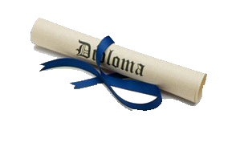

CATALOG — BELLASA PROFESSIONAL INSTITUTE 10

CANCELLATION AND REFUND POLICY
Refunds, when due, are made within 30 days of (1) the last day of
attendance if written notification has been provided to the institution by the student, or (2) are made within 30 days from the date the institution terminates the student or determines withdrawal by stu- dent. Retention of tuition and fees collected in advance for a student who does not commence class does not exceed $100.

Should a student’s enrollment be terminated or cancelled for any rea- son, all refunds will be made according to the following refund
schedule.
- Cancellations can be made in person, by electronic mail, by Certified Mail or by termination.
- All monies will be refunded if the school does not accept the appli- cant or if the student cancels within three (3) business days after
signing the enrollment agreement and making initial payment.
- Cancellation after the third (3rd) Business Day, but before the first class, will result in a refund of all monies paid, except for the registration fee (not to exceed $150.00).
- Cancellation after attendance has begun, through 50% completion of the program, will result in a Pro Rata refund computed on the number of hours completed to the total program hours.
- Cancellation after completing more than 50% of the program will result in no refund.
- Termination Date: When calculating the refund due to a student, the last date of actual attendance by the student is used in the calculation unless earlier written notice was received.
- Refunds will be made within 30 days of termination of the student’s enrollment or receipt of a Cancellation Notice from the student.

TRANSCRIPTS AND DIPLOMAS

A student may review their file in the office providing they have made an appointment with the director. After graduation or departure from the school a transcript or duplicate diploma may be requested. The school permanently maintains records of academic progress. Records of academic progress will be furnished to the student upon his or her request.

OFFICE OF FINANCIAL AID

The Federal Pell Grant is an important source of aid for students. The amount of the award depends upon the determine- tion of the student’s eligibility based on the U.S. Department of Education guidelines. Pell grants do not have to be repaid.

Financial need is based on an analysis of information provided by the student on a Free Application for Federal Student Aid (FAFSA) form.

WHO QUALIFIES FOR FINANCIAL AID

To be considered eligible for and receive Title IV aid, a student must meet the following specific requirements: Be a U.S. citizen or eligible non-citizen.
Be a “regular student” – that is, enrolled in an eligible program that leads to a degree, certificate, or a degree-with- transfer program.
Not be enrolled simultaneously in elementary or secondary school Have a valid Social Security Number
Be registered with Selective Service, if required
Sign a Statement of Educational Purpose certifying that federal student financial aid will only be used to pay educational costs.
Not be in default on a Title IV loan; or if in default, have made satisfactory repayment arrangements with the loan holder have not obtained loan amounts that exceed annual or aggregate loan limits made under any Title IV loan program.
Not have been convicted of an offense involving the possession or sale of illegal drugs that occurred while the student was enrolled and receiving Title IV aid.
Have completed repayment of funds to either Department of Education or the holder of a loan, if applicable
Not have been convicted of, or plead nolo contendere or guilty to, a crime involving fraud in obtaining Title IV and not be liable for an overpayment of a Title IV grant.

APPLYING FOR FINANCIAL AID
The application process used by the University to perform the need analysis is the Free Application for Federal Student Aid
(FAFSA). The FAFSA can be completed online by logging on to www.fafsa.gov. When completing the FAFSA, please use the University’s school code #042736.

A student’s income tax form (if filed) and/or parent's tax form(s) for the appropriate year are needed to complete the FAFSA. Students are encouraged to use the IRS Data Retrieval Tool when completing the FASFA. This tool allows students and par- ents to access the IRS tax return information needed to complete the FASFA and transfer the data directly to their FASFA. If students need a copy of their tax return, they can call 1-800-829-1040 and request IRS tax transcript or go to the IRS web- site at www.irs.gov.

NOTE: Bellasa Professional Institute does not participate in Federal Direct Loans

All students requesting federal loans must complete an Entrance Counseling and a Master Promissory Note (MPN) which can be found at https://studentloans.gov.

The student will also need to meet with a Financial Aid representative to fill out the Financial Aid forms and provide documentation for information entered on their FAFSA.

STUDENTS RESPONSIBILITIES WITH THE OFFICE OF FINANCIAL AID

Protecting, maintaining, and renewing financial aid is a very important responsibility for all students. A student’s financial aid responsibilities include the following:

Acknowledging and meeting all deadlines for applying /reapplying for Financial Aid Providing complete and accurate information on the FAFSA and financial aid forms
Responding to all requests for additional documentation in a timely manner
Providing updated information when changes occur such as a withdrawal from university, a change in enrollment status, name, marital status or expected date of graduation.
Being in good Academic Standing with the University as well as maintaining Satisfactory Academic Progress (SAP) Reading all documents, the Office of Financial Aid sends to the student.

Misreporting information for Federal Financial Aid is a violation of the law and is considered a criminal offense.

CATALOG — BELLASA PROFESSIONAL INSTITUTE 11

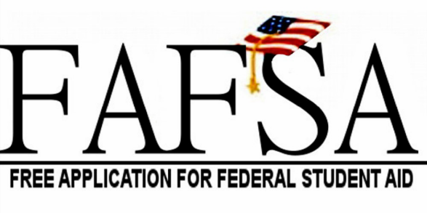
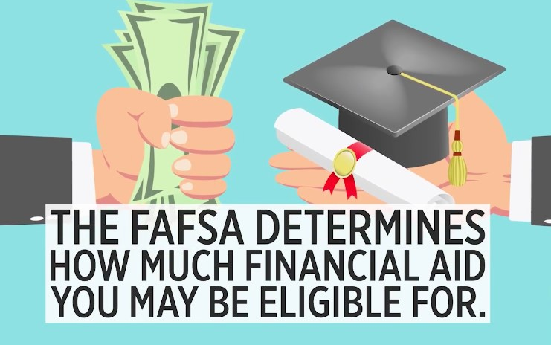

RETURN TO TITLE IV (R2T4)
(FOR TITLE IV FINANCIAL AID)
(APPLIES TO THE PAYMENT PERIOD THE STUDENT IS IN AT WITHDRAWAL/ TERMINATION)
The law specifies how a school must determine the amount of Title IV program assistance that a student earns if he/she withdraws from school. The Title IV
programs that are covered by this law are: Federal Pell Grants, Direct Student Loans, PLUS Loans, and Federal Supplemental Educational Opportunity Grants
(FSEOGs).

NOTE: Bellasa Professional Institute does not participate in the Federal Direct Loan Program so only Federal Pell Grant is used in this calculation.

All R2T4 calculations are completed within 30 days from the Date of Determination (DOD) and all refunds back to the US Department of Education are returned
within 45 days from the DOD.
When a student withdraws during the payment period the amount of Title IV program assistance that he/she has earned up to that point is determined by
a specific formula. If the student received (or the school or parent received on the student’s behalf) less assistance than the amount that the student earned,
the student may be able to receive those additional funds. If the student received more assistance than he/she earned, the excess funds must be returned by
the school and/or the student.

The amount of assistance that the student has earned is determined on a pro-rata basis. For example, if the student completed 30% of the scheduled hours
in their payment period, the student earns 30% of the assistance he/she was originally scheduled to receive. Once the student has completed more than 60%
of the scheduled hours in his/her payment period, the student earns all the assistance that he/she was scheduled to receive for that period.
If the student did not receive all the funds that he/she earned, the student may be due a Post withdrawal disbursement. If the Post-withdrawal disbursement
includes loan funds, the academy must get the student’s permission before it can disburse them. The student may choose to decline some or all of the loan funds
so that he/she doesn’t incur additional debt. The academy may automatically use all or a portion of the post-withdrawal disbursement of grant funds for tuition,
fees, and room and board charges (as contracted with the academy).

The school needs the student’s permission to use the post-withdrawal grant disbursement for all other school charges.
There are some Title IV funds that the student was scheduled to receive that cannot be disbursed to him/her upon withdrawal because of other eligibility
requirements. For example, if the student is a first-time, first-year undergraduate student and has not completed the first 30 days of the program before
withdrawal, the student will not receive any Direct Loan funds that they would have received had they remained enrolled past the 30th day. If the student receives
(or the academy or parent receives on their behalf) excess Title IV program funds that must be returned, the academy must return a portion of the excess equal
to the lesser of: the institutional charges multiplied by the unearned percentage of the student’s funds, or the entire amount of excess funds. The academy must
return this amount even if it didn’t keep this amount of the student’s Title IV program funds.

If the Academy is not required to return all of the excess funds, the student must return the remaining amount. Any loan funds that the student must return,
he/she (or the parent for a PLUS Loan) repay in accordance with the terms of the promissory note. That is, the student makes scheduled payments to the holder
of the loan over a period of time.

Any amount of unearned grant funds that the student must return is called an overpayment. The maximum amount of a grant overpayment that must be repaid
is half of the grant funds the student received or was scheduled to receive. The student must make arrangements with the academy or the Department of Education
to return the unearned grant funds.

The requirements for Title IV program funds when a student withdraws are separate from any Institutional Refund Policy that the academy may have. Therefore,
the student may still owe funds to the academy to cover unpaid institutional charges. The academy may also charge for any Title IV program funds that the school
was required to return. If a student has questions about his/her Title IV program funds, he/she can call the Federal Student Aid Information Center at
1-800-4-FEDAID (1-800-433-3243). TTY users may call 1-800-730-8913. Information is also available on Student Aid on the Web at www.studentaid.ed.gov.

CATALOG — BELLASA PROFESSIONAL INSTITUTE 12

COSMETOLOGY PROGRAM

1200 HOURS – 50 WEEKS

OBJECTIVE
The cosmetology program is to prepare students for entry level positions as a cosmetologist in salon and spa or other beauty facilities. The theory classes include the biological study of hair and its function. Instruction will also be given in chemistry, sterilization, bacteriology and hygiene. At the completion of this program, graduates will qualify to apply for the state license examination and employment in the beauty industry. A diploma will be awarded upon graduation from the cosmetology program.
DESCRIPTION
This program is offered 20 hours per week for a total of 50 weeks. Students will receive quizzes, tests, and practical evaluations in each course. This program consists of 1200 hours and 620 hours/service on hands on instruction and practice of applied application.
PROGRAM BREAKDOWN BY COURSE | LECTURE HOURS | LAB HOURS | SERVICES
COS101 HIV/AIDS | 4
COS102 FLORIDA LAW | 15
COS103 Bacteriology, Sanitation and Sterilization | 20
COS104 Hair and Scalp Treatment | 20 | 45 | 45
COS105 Draping, Shampoo and Rinsing | 15 | 50 | 50
COS106 Hair Cutting/Shaping | 125 | 75 | 75
COS107 Hair Styling | 110 | 300 | 300
COS108 Chemical relaxing/Straightening and  Waving | 70 | 65 | 65
COS109 Hair Coloring | 70 | 45 | 45
COS110 Manicure, Pedicure and Nail Extensions | 56 | 20 | 20
COS111 Facials, Make-Up and Hair Removal | 50 | 20 | 20
COS112 Salon Management | 25
Total Clock Hours 1200 | 580 | 620

PROGRAM COST  Tuition | 9,000.00
Book | 475.00
Registration Fee | 150.00
Lab fees | 1,580.00
Program Kit | 2,500.00
School T-Shirt | 120.00
Cost of Attendance | $13,825.00

CATALOG — BELLASA PROFESSIONAL INSTITUTE 13

COURSE DESCRIPTION

COS101 HIV/AIDS
Students will learn the origin, transmission and prevention of HIV/AIDS required by Florida Statute, “guidelines” and principle of cleanliness and safety. The different procedures for protection against the spread of disease.

COS102 FLORIDA LAW
Students will learn the laws and regulations pertaining to Cosmetology, as set by the Department of Business and Professional Regulations. Students will study Professional Ethics.

COS103 BACTERIOLOGY, SANITATION AND STERILIZATION
This unit will introduce the student to the various classifications of bacteria and how bacteria grow in the salon. Further,
methods of health, sterilization, sanitation, and infection control, as well as sterilization rules, regulations, and procedures will be covered.

COS104 HAIR AND SCALP TREAMENT
This unit will introduce all basic aspects of the hair and scalp: principles, techniques, properties, growth, analysis, treatments, hair loss, etc. Hair and scalp disorders will also be examined. The students will be given the knowledge of the different products and manipulations.

COS105 DRAPING, SHAMPOO AND RINSING
The students will learn proper hair maintenance and the objective of the wash, the frequency, the products designed for each type of condition or alteration. Students will learn the structure of the face and neck: bones, muscles, and nerves. Students will also learn effective means of manipulating the scalp to maintain muscle tone and increase blood circulation.

COS106 HAIR CUTTING/SHAPING
Students will learn hair cutting for women, men and children, and the various hair cutting methods used in the industry. Principles and techniques of hair cutting are covered.

COS107 HAIR STYLING
Principles and techniques of hair styling are covered. Styling methods will be taught; differences in blow-drying and roller styling; types of roller sets. This unit will also cover principles and techniques of hair extensions. The differences in roller styling; blow-drying; types of roller sets; styling methods and designs.

COS108 CHEMICAL RELAXING/STRAIGHTENING AND WAVING
The course instructs students on the effects of cosmetics and skin care products on the skin. Students will learn the composition of cosmetics and effects of product chemistry on the hair. Cosmetic chemistry will also be covered. In this unit, the student will also learn about human cells, anatomy and physiology. This course will provide information on materials used in the
straightening/relaxing process and its purpose. Safety of product use will be taught as well.

COS109 HAIR COLORING
Principles and techniques of hair coloring are introduced. Principles of color theory; Hair color preparations, including client consultation; safety precautions for coloring; hydrogen
peroxide; special coloring; correction of coloring problems.

COS110 MANICURE, PEDICURE AND NAIL EXTENSIONS
This unit will introduce the student to the nail care industry, including principles, techniques, implements and tools, manicure table preparation, various styles of manicure, pedicure and massages. The unit will also cover nail disorders and diseases, along with basic instruction on nail extensions (i.e., acrylics, gel, etc.).

COS111 FACIALS MAKE UP AND HAIR REMOVAL
The student will be introduced to the principles and techniques of skin care, including facial treatments, facial manipulations; the skin and its disorders; make-up. Students will learn three methods of hair removal: Tweezing, Waxing, and Chemical
depilatories. The student will also be introduced to the safety guidelines of waxing, chemical depilatories, and the proper method to shape brows.

COS112 SALON MANAGEMENT
Students will be introduced to salon management. Emphasis will be placed on rules for professional behavior with clients, employers, and co-workers. Salon safety and professional appearance will also be covered.

CATALOG — BELLASA PROFESSIONAL INSTITUTE 14

ELECTROLOGY PROGRAM
320 HOURS – 16 WEEKS

OBJETIVE
The program is designed to train students in permanent hair removal by electrology. The courses are designed to give the students thorough entry-level preparation to work in the field of electrology. The modern short wave, blend, and galvanic methods are taught in small classes and students gain hands-on experience through clinical applications. Upon successful completion of the program, graduates may apply for the state licensing exam and the national certification testing. A diploma will be awarded upon graduation from the program.

DESCRIPTION
This program consists of 120 hours of theory and 200 hours of applied practical training. A diploma will be awarded upon graduation from the program.

PROGRAM COST
PROGRAM BREAKDOWN BY COURSE | LECTURE HOURS | LAB | SERVICES
 |  | HOURS
HIV102 Bloodborne Pathogens Training for Electrology: HIV/AIDS | 5
ELE110 Introduction to Electrology and History of Hair Removal | 15
ELE115 Florida State Law & Regulations Governing Electrology | 5
ELE120 Basic Electricity and Chemistry for Elec- trology, Equipment, Techniques, and Procedures | 5
ELE130 Bacteriology, Sanitation, and Sterilization | 7
ELE135 Integumentary System | 6
ELE140 Circulatory System | 6
ELE145 Endocrine System and Diseases of the Glands | 6
ELE150 Biology of Hair Growth and Disorders | 10
ELE155 Skin Assessment, Skin Type, Effect of all Modalities of Temporary Hair Removal | 20
ELE160 Consultations, Medical History, Contraindications and Complications | 20
ELE165 Clinic and Office Management, Ethics, Bookkeeping and Patient Management | 5
ELE 170 Laser and light-based hair removal physics | 5
ELE 171 Laser safety and precautions | 5
ELE175 Clinical Applications & Lab Hours (200 hours): |  | 200 | 75
Total Clock Hours 320 | 120 | 200 | 75

Tuition | 4,680.00
Books, Lab & T-Shirt | 910.00
Registration fee | 150.00
Other Costs | 0.00
Cost of Attendance | $5,740.00

CATALOG — BELLASA PROFESSIONAL INSTITUTE 15

COURSE DESCRIPTION

HIV102 Bloodborne Pathogens Training HIV/AIDS The study of the growth and
transmission of the AIDS virus, legal and ethical implications for client care, and prevention of diseases by blood borne pathogens. (Prerequisite: None)

ELE110 Introduction to Electrology and History of Hair Removal This course explores the basic concepts of electrology including the types of current used, procedures for temporary hair removal, and the development of hair removal techniques in ancient and present times. (Prerequisite: None)

ELE115 Florida State Laws and Regulations Governing Electrology Students are instructed in the rules and regulations set by the State of Florida and the other governing bodies to include Electrolysis standards, training, and licensure. (Prerequisite: None)

ELE120 Basic Electricity and Chemistry for Electrology, Equipment, Techniques, and Procedures This course introduces students to the sources and types of electricity, the three modalities used in electrology, the types of equipment and safety precautions for the Electrologist. Additionally, students will be instructed in electrical and chemical effects on the skin. (Prerequisite: None)

ELE130 Bacteriology, Sanitation, and Sterilization Students will learn different types of bacteria, bacterial growth and symptoms of bacterial infections. They will learn all the approved methods of sterilization, types of disinfectant agents used in Electrology facilities, and the precautions related to sterilization and sanitation. (Prerequisite: None)

ELE135 Integumentary Systems Students will learn the structure and function of hair and skin relating to Electrology and histology of the follicle and associated organs. (Prerequisite: None)

ELE140 Circulatory Systems Students will be instructed in the primary function of the vascular and circulatory systems and in the maintenance of good health. (Prerequisite: None)

ELE145 Endocrine Systems and Diseases of the Glands Students will learn the elements of the endocrine system and the glands which cause excess hair growth, types of glandular disease, and the effects of hormonal changes on hair growth. (Prerequisite: None)

ELE150 Biology of Hair Growth and Disorders This course details the biological makeup of hair follicles and their development. Students will explore dermatology and skin disorders. Students will learn to recognize abnormal skin conditions and suggest appropriate treatment options. (Prerequisite: None)

ELE155 Skin Assessment and Temporary Hair Removal Students will learn to analyze skin and differentiate skin types and assess the effects of temporary hair removal to apply proper treatment procedures and machine settings. (Prerequisite: None)

ELE160 Consultations This course teaches students the professional aspects of personal and phone consultations regarding assessment, contraindications, supplying information essential to the client’s informed consent and providing a clean and relaxed atmosphere conducive to the client’s overall comfort. (Prerequisite: None)

ELE165 Successful Business Management Students will be introduced to the requirements and regulations for starting and/or managing an electrology clinic. Professional ethics and integrity are discussed, and regulations and office procedures are reviewed. (Prerequisite: None)

ELE175 Clinical Applications & Lab Hours Coordination Skills with probe holder and forceps (5 hrs),

Insertions (15 hrs), Sanitation / Sterilization procedures (10 hrs), Hands on equipment instruction (Galvanic) (5 hrs), Hands on equipment instruction (Thermolysis)(5 hrs), Hands on equipment instruction (Blend) (5 hrs), Client Pre/Post treatment (5 hrs), Client Assessment (10 hrs), General Treatment Procedures (105 hrs),
Consultation (15), Visuals/Library (10hrs), Review/Exam Preparation (10 hrs)

CATALOG — BELLASA PROFESSIONAL INSTITUTE 16

FACIAL SPECIALIST PROGRAM
260 HOURS—13 WEEKS

OBJECTIVE
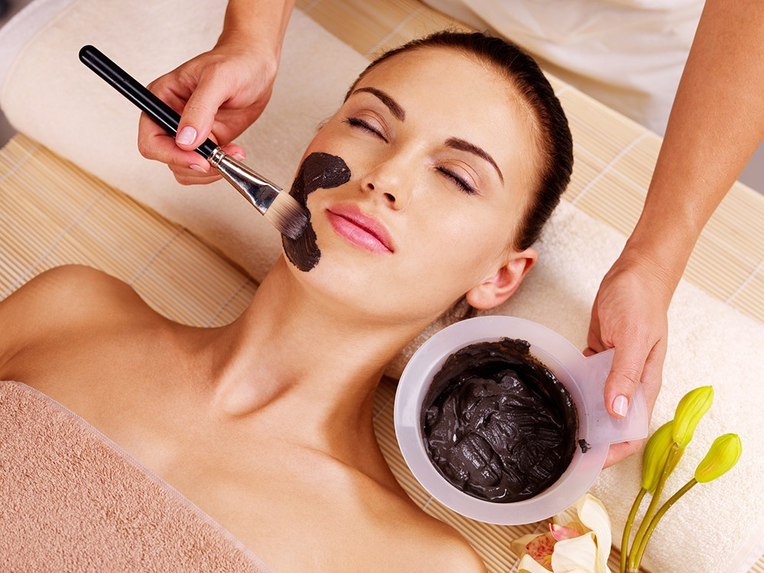
This program provides training in skin treatments teaching students skin analysis and facial techniques to maintain the skin health with the proper cleansing methods, massage, and the use of machines for deep cleansing. Theory classes and hands-on practical applications give the students’ knowledge and experience to gain entry level employment in the skin care field. Upon completion of this program a diploma will be awarded, and graduates will qualify to apply for State Registration as a Facial Specialist.

DESCRIPTION
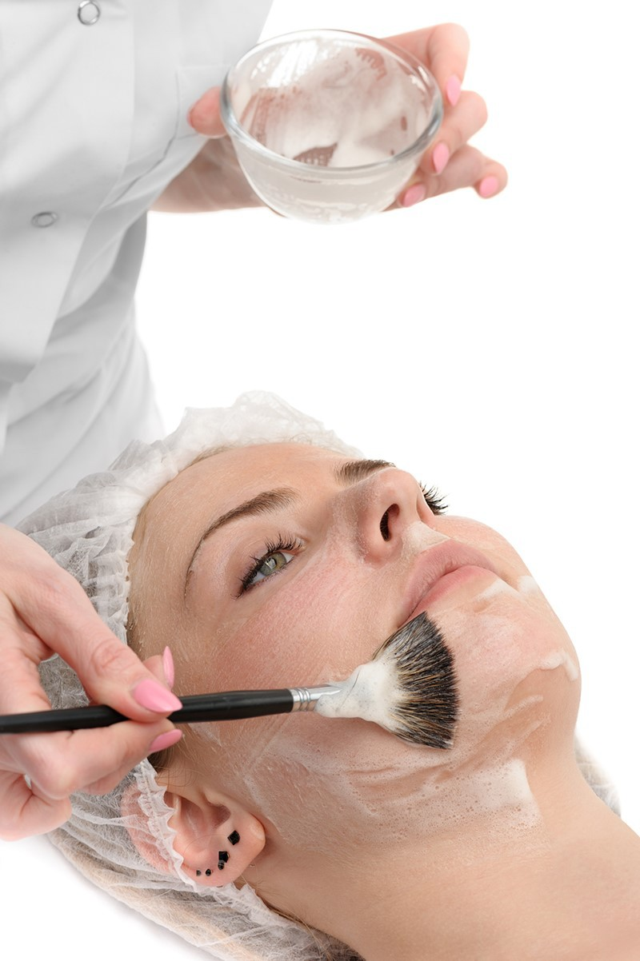
This program consists of 140 hours of theory and 140 hours of applied practical training. A diploma will be awarded upon graduation from the program.
PROGRAM BREAKDOWN BY COURSE | LECTURE HOURS | LAB HOURS | SERVIC ES
FSP010 Florida State and Regulations | 5
HIV101 HIV/AIDS Training | 4
FSP120 Bacteriology, Sterilization, Hygiene and Sanitation | 10
FSP130 Chemistry, Product and Product Safety | 8
FSP135 Basic Electricity, Lighting and Magnification | 8
FSP145 Skin Theory, Basic Dermatology, Skin Disorders and Skin Diseases | 85
FSP150 Basic Facial and Treatments, Consultation, Contraindications | 66
FSP155 Hair Growth, Removal and Waxing | 2.5
FSP160 Make-Up Application and Cosmetology Treatments | 2
FSP165 Professionalism, Ethics and Salon Management | 2
FSP170 Applied Clinical Training (100 Services) |  | 67.5 | 100
Total Clock Hours 260 | 192.5 | 67.5 | 100

PROGRAM COST
Tuition | $2,380.00
Book | 250.00
Registration fee | 150.00
Kit & Lab | 875.00
School T-Shirt | 60.00
Cost of Attendance | $3,715.00

CATALOG — BELLASA PROFESSIONAL INSTITUTE 17

COURSE DESCRIPTION

FSP010 Florida State Law & Regulations

The study of Florida state laws regulating the field and practice of skin care set by the Department of Professional Regulations. (Prerequisite: None)
HIV101 HIV/AIDS Training The study of the law, awareness, and precautions for the prevention of HIV/ AIDS transmission and other bloodborne pathogens.
FSP120 Bacteriology, Sterilization, Hygiene and Sanitation This course teaches students about bacteria and how to prevent the spread of disease, including the proper methods of sterilization and hygiene. (Prerequisite: None)

FSP130 Chemistry, Products, and Product Safety This course instructs students on the effects of cosmetics and skin care products on the skin. Basic chemistry is fundamental in choosing the correct products for each client’s skin type. (Prerequisite: None)

FSP135 Basic of Electricity, Lighting and Magnification The proper use and measurement of electricity in working with the skin are examined. Students will be taught polarity and the different types of current used in skin care. (Prerequisite: None)

FSP145 Skin Theory, Basic Dermatology, Skin Disorders, and Skin Disease Students will be instructed in the knowledge of skin disorders and diseases and the analysis and treatment of these disorders. Before performing services or selecting products, the client's skin type and conditions must be analyzed, and appropriate treatment determined. This course includes the study of the structure and composition of tissue as well as the study of function of the skin. Students will be instructed in the effects that each service performed will have on the client’s skin. (Prerequisite: None)

FSP150 Basic Facials and Treatments, Consultations, Contraindication The basic facial treatment protocol is studied in this course including the general routine and alternate methods depending on the client’s needs. Students will be instructed in preparing the client pre- and post-treatment. (Prerequisite: None)

FSP155 Hair growth, Removal, and Waxing This course teaches students the hair growth cycle and methods of removing unwanted hair. Safety precautions are studied for each method of hair removal. (Prerequisite: None)

FSP160 Make-up Application and Cosmetology Treatments Students will learn the different types of cosmetics and the proper application including color selection. The student will be trained in the identification of different facial types and the procedures for corrective makeup. (Prerequisite: None)

FSP165 Professionalism, Ethics, and Salon Management Students will be introduced to the requirements and regulations for starting and/or managing a business in skin care. Professional ethics and integrity are discussed, and regulations and office procedures are reviewed. (Prerequisite: None)

FSP170 Applied Clinical Training (100 services) Students will practice practical hands-on applications of all subjects taught in the program on fellow students and clients. (Prerequisite: All didactic courses)

CATALOG — BELLASA PROFESSIONAL INSTITUTE 18

FULL SPECIALIST PROGRAM
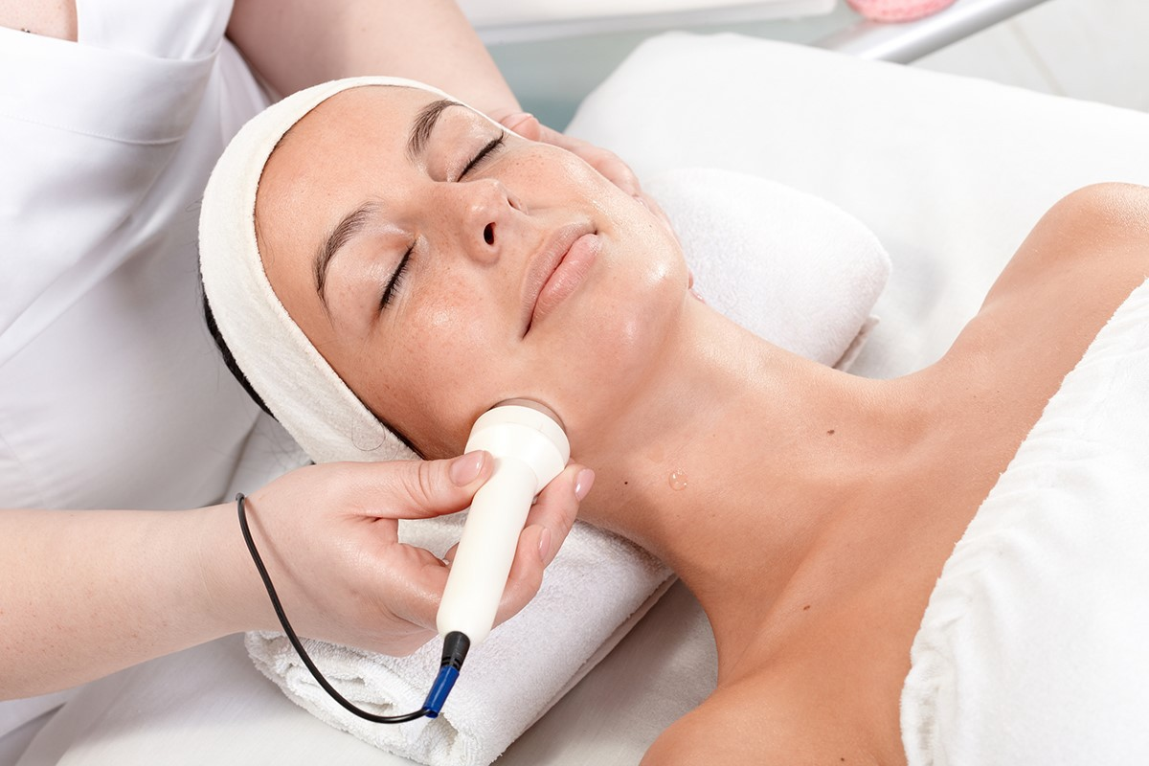
600 CLOCK HOURS—30 WEEKS
ELIGIBLE FOR FINANCIAL AID

OBJECTIVE:
The program is designed to teach students the understanding and practical theory of the skin and the art and science of beautifying the nails, hands, and feet; to give a proper massage; and to use safety precautions and sanitation methods in manicuring, pedicuring and extending the nails. Techniques will be learned in identifying nail diseases, the basic type of artificial nails and nail extensions. At the completion of this program, graduates will qualify to apply for state registration and employment in the beauty industry. A diploma will be awarded upon graduation from the program.
PROGRAM BREAKDOWN BY COURSE | LECTURE HOURS | LAB HOURS | SERVICES
FS100 Florida State Law & Regulations (Nail tech) | 5
FS101 HIV/AIDS | 4
FS102 Sanitation & Sterilization | 4
FS103 Ethics & Shop Management (Nail Tech) | 2
FS104 Manicures |  | 20 | 20
FS105 Pedicures |  | 10 | 10
FS106 Tips with Overlay |  | 37.5 | 15
FS107 Sculpting |  | 37.5 | 15
FS108 Nail Wraps & Mending |  | 15 | 10
FS109 Nails Capping & Fill Ins |  | 10 | 10
FS110 Artificial Nail Removal |  | 5 | 5
FS111 Nail Theory, Disorders & Diseases of the Nail | 85
FS112 Polish & Nail Art |  | 5 | 10
FS113 Florida State Law & Regulations (Skin Care) | 5
FS114 Bloodborne Pathogens. HIV/AIDS | 4
FS115 Skin Theory, Disease and Disorders of the Skin | 50
FS116 Basic Dermatology, Skin Disorders | 15
FS117 Anatomy & Massage Manipulations | 10
FS118 Consultations | 5
FS120 Physiology & Endocrinology (Diseases of the Glands) | 5
FS121 Bacteriology, Sterilization, Hygiene | 10
FS122 Chemistry & proper Use of Products | 8
FS123 Hair Removal (Body Waxing & Brow Shaping) | 2.5
FS124 Make-Up Application and Cosmetic Treatments | 2
FS125 Electricity, Lighting & Magnification | 8
FS126 Professional Ethics | 2
FS127 Facial Techniques and Contraindications | 66
FS128 Salon Management | 60
FS129 Salon Retail | 40
FS130 Applied Clinical Training/Services: ( See Details on page 16) |  | 67.5 | 100
Total Clock Hours 600 | 392.5 | 207.5 | 195

DESCRIPTION:
The full specialist program consists of 600 clock hours, 392.5 hours of theory

PROGRAM COST
Tuition | 5,000.00
Books | 500.00
Registration Fee | 150.00
Nail Kit | 725.00
Lab fees | 930.00
School T-Shirt | 120.00
Cost of Attendance | $7,425.00

CATALOG — BELLASA PROFESSIONAL INSTITUTE 19

COURSE DESCRIPTION
FS100 FLORIDA STATE LAW & REGULATION (NAIL TECH) Students will learn what is necessary to comply with local, state, and federal regulations and laws.
FS101 HIV/AIDS Students will learn the origin, transmission and prevention of HIV/AID required by Florida Statute.
FS102 SANITATION & STERILIZATION Students will learn the guideline and principle of cleanliness and safety. The different procedures for protection against the spread of disease.
FS103 ETHICS & SHOP MANAGEMENT Students will learn the Business aspect in the field of cosmetology. Maintaining accurate records, managing personnel, and selling products.
FS104 MANICURES Students will learn all the abilities of a manicurist, proper use of implements and material used when doing a manicure.
FS105 PEDICURE Students will learn the basic procedure when conducting a pedicure, equipment, implements and materials. FS106 TIPS WITH OVERLAY Students will learn how to extend the natural nail artificially by using tips, buffing, applying nail glue, placing the tips and filling.
FS107 SCULPTING The students are taught how to create and extension using only acrylic liquid. Students learn the precautions and proper procedure to sculpt nails in different types of nail beds. Supplies and chemistry of acrylic nails.
FS108 NAIL WRAPS & MENDING Students will learn to wrap nails with the four types of wraps and how to repair natural nails. FS109 NAIL CAPPING & FILL INS Students will learn how to maintain the artificial nail using acrylic to fill in between the new growth area of the nail.
FS110 ARTIFICIAL NAIL REMOVAL Students will learn the proper procedure to remove acrylic nails.
FS111 NAIL THEORY, DISORDERS & DISEASES OF THE NAIL Students will learn and study about the structure of the nail. The technical terms, the parts of the nail, defining the types of disorders and handling customer with nail disorders.
FS112 POLISH & NAIL ART Students will learn the creative part of nail painting, from what supplies to use to the applicant. Application of nail tapes, gems and foil is studied and practiced. The use of air brush for decoration is reviewed.
FS113 Florida State Law & Regulations (SKIN CARE) The study of all laws pertaining to Skin Care set by the Department of Professional Regulations.
FS114 Bloodborne Pathogens Training: HIV/AIDS This course teaches the students the origin, transmission, and prevention of HIV/AIDS as required by Florida Statute.
FS115 Skin Theory Skin Theory, Diseases and Disorders of the skin.
FS116 Basic Dermatology and Skin Disorder the Study and understanding the composition of the skin, learn to recognize diseases, disorders of the skin, and recognize skin types.
FS117 Anatomy & Massage Manipulations The study and understanding of the bones, muscles and nerves of the face and neck. Means of manipulation of the face to maintain muscle tone and increase circulation. Using the correct products for the skin.
FS118 Consultations Student will learn how to handle a consultation in person or by telephone.
FS120 Physiology & Endocrinology (Diseases of the Glands) Student will learn histology of the skin and hair. Understanding the composition, structure and function of the skin will help the students know what effects the service performed will have on the client’s skin. Endocrinology will include the study of the endocrine glands and their function.
FS121 Bacteriology, Sterilization, Hygiene Application of sterilization and sanitation methods. Classification of pathogenic bacteria and know how pathogenic bacteria causes diseases.
FS122 Chemistry & proper Use of Products Students will learn the composition of cosmetics. Effect of chemistry of cosmetics on the skin, safety of cosmetics and skin preparation.
FS123 Hair Removal (Body Waxing & Brow Shaping) Student will learn three methods of hair removal, tweezing, waxing and chemical depilatories. Safety of waxing and chemical depilatories.
FS124 Make-Up Application and Cosmetic Treatments The students will learn the correct application of makeup, how to use the color wheel, daywear make-up, evening make-up and procedures of make-up.
FS125 Electricity, Lighting & Magnification Student will learn polarity and current flow, measurements of electricity and safety precautions.
FS126 Professional Ethics Students will learn professional ethics, integrity and attitudes. Setting up a Salon or starting business,
State Regulations, obtaining proper licenses, advertising, record keeping, insurance and compensation package and payroll deductions. FS127 Facial Techniques and Contraindications The basic facial treatment protocol is studied in this course including the general routine and alternate methods depending on the client’s needs. Students will be instructed in preparing the client pre and post-
treatment.
FS128 Salon Management Students will be introduced to the proper salon organization, bookkeeping, taxes requirement, employee hiring, type of insurance, appointments, site selection and telephone techniques.
FS129 Salon Retail Students will learn product knowledge, storage, and inventory display, inventory pricing and good selling skills. FS130 Applied Clinical Training/Services Students will practice applications of all subjects taught to fellow students and clients. Facials, manual and mechanical, including masks, packs or treatments which must be performed on a variety of skin types including normal, dry, combination, problem and mature skin (40 hours, 40 services). Set Up, use and maintenance of electrical devices (1.25 hours, 5 services). Hair removal, including tweezing, waxing, threading and sugaring (5 hours, 20 services). Make-Up Applications for both daytime and nighttime looks (5 hours, 10 services). Lash and Brow tinting (5 hours, 10 services). Eyelash application, Including
strip lashes, individual lashes and semi-permanent lashes (10 hours, 10 services). Manual Extractions (1.25 hours, 5 services)

CATALOG — BELLASA PROFESSIONAL INSTITUTE 20

NAIL TECHNOLOGY PROGRAM
240 HOURS - 10 WEEKS

OBJECTIVE:
This program is designed to teach students the art and science of beautifying the nails, hands, and feet; to give a proper massage; and to use safety precautions and sanitation methods in manicuring, pedicuring and extending the nails. Techniques will be learned in identifying nail diseases, the basic type of artificial nails and nail extensions. At the completion of this program, graduates will qualify to apply for state registration and employment in the beauty industry. A diploma will be awarded upon graduation from the program.

DESCRIPTION:
The nail program consists of 240 clock hours, 100 hours of theory and 140 hours of lab. It also has 80 services to be per- formed in class.
PROGRAM BREAKDOWN BY COURSE | LECTURE HOURS | LAB-  HOURS | SERVICES
NAIL 101 HIV/AIDS | 4
NAIL 102 Sanitation & Sterilization | 4
NAIL 103 Ethics & Shop Management | 2
NAIL 104 Manicure |  | 20 | 20
NAIL 105 Pedicure |  | 10 | 10
NAIL 106 Tips with Overlay |  | 37.5 | 15
NAIL 107 Sculpting |  | 37.5 | 15
NAIL 108 Nail Wraps & Mending |  | 15 | 10
NAIL 109 Nail Capping & Fill Ins |  | 10 | 10
NAIL 110 Artificial Nail Removal |  | 5 | 5
NAIL 111 Nail Theory, Disorders & Diseases of the Nail | 85
NAIL 112 Polish & Nail Art |  | 5 | 10
NAIL 113 Florida State Law & Regulations | 5
Total Clock Hours 240 | 100 | 140 | 95

PROGRAM COST
Tuition 995.00
Book, Lab, Program Kit T-shirt 985.00 Registration Fee 150.00

Cost of Attendance $2,130.00

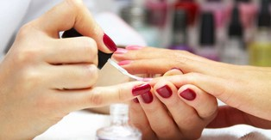

CATALOG — BELLASA PROFESSIONAL INSTITUTE 21

COURSE DESCRIPTION

NAIL101 HIV/AIDS:
Students will learn the origin, transmission and prevention of HIV/AID required by Florida Statute

NAIL102 SANITATION & STERILIZATION:
Students will learn the guidelines and principle of cleanliness and safety. The different procedures for protection against the spread of disease.

NAIL103 ETHICS & SHOP MANAGEMENT:
Students will learn the Business aspect in the field of cosmetology. Maintaining accurate records, managing personnel, and selling products.

NAIL104 MANICURES:
Students will learn all the abilities of a manicurist, proper use of implements and material used when doing a manicure.

NAIL105 PEDICURE:
Students will learn the basic procedure when conducting a pedicure, equipment, implements and materials

NAIL106 TIPS WITH OVERLAY:
Students will learn how to extend the natural nail artificially by using tips, buffing, applying nail glue, placing the tips and filling.

NAIL107 SCULPTING:
The students are taught how to create and extension using only the acrylic liquid. Students learn the precautions and proper procedure to sculpting nails in different types of nail beds. Supplies and chemistry of acrylic nails.

NAIL108 NAIL WRAPS & MENDING:
Students will learn to wrap nails with the four types of wraps and how to repair natural nails.

NAIL109 NAIL CAPPING & FILL INS:
Students will learn how to maintain the artificial nail using acrylic to fill in between the new growth area of the nail.

NAIL110 ARTIFICIAL NAIL REMOVAL:
Students will learn the proper procedure to remove acrylic nails.

NAIL111 NAIL THEORY, DISORDERS & DISEASES OF THE NAIL:
Students will learn and study about the structure of nails. The technical terms, the parts of the nail, defining the types of disorders and handling customer with nail disorders.

NAIL112 POLISH & NAIL ART:
Students will learn the creative part of nail painting, from what supplies to use to the applicant. Application of nail tapes, gems and foil is studied and practiced. The use of air brush for decoration is reviewed.

NAIL113 FLORIDA STATE LAW & REGULATION:
Students will learn what is necessary to comply with local, state, and federal regulations and laws.

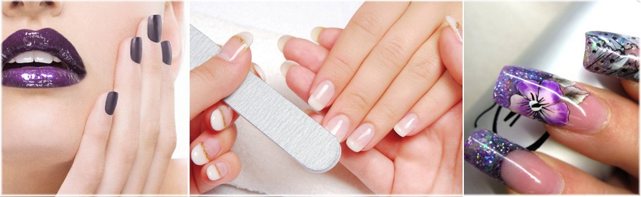

CATALOG — BELLASA PROFESSIONAL INSTITUTE 22

Medical Aesthetician Program
PROGRAM BREAKDOWN BY COURSE
Course  Number | Course Title | Clock  Hours | Credit  Hours | Services  (If Applicable)
ELS100 | Florida State Law and Regulations for Skincare | 5
ELS101 | Bloodborne Pathogens HIV/AIDS for Skincare | 4
ELS102 | Bacteriology. Sterilization, Hygiene and Sanitation | 10
ELS103 | Chemistry, Product and Product Safety | 8
ELS104 | Basic Electricity and Magnification | 8
ELS105 | Disorders of the Skin | 85
ELS106 | Basic Facials and Treatments, Consultation and Contraindications | 66
ELS107 | Hair Growth, Removal and Waxing | 2.5
ELS108 | Makeup Application and Cosmetic Treatments | 2
ELS109 | Professional Ethics and History | 2
ELS110 | Salon Management and Care | 20
ELS111 | Basics of Nutrition | 20
ELS112 | Skin Care Lab hours, Clinical Applications and Services | 67.5 |  | 100
ELS113 | Bloodborne Pathogens HIV/AIDS for Electrology/Laser | 10
ELS114 | Florida State Law and Regulations for Electrology/Laser | 10
ELS115 | Introduction to Electrology and History of Hair Removal | 15
ELS116 | Basic Electricity and Chemistry, Equipment, Techniques and Procedures for Electrology | 5
ELS117 | Bacteriology, Sanitation and Sterilization for Electrology | 10
ELS118 | Integumentary System | 10
ELS119 | Circulatory System | 10
ELS120 | Endocrine System and Diseases of the Glands | 10
ELS121 | Biology of Hair Growth and Disorders | 10
ELS122 | Skin Assessment and Temporary Hair Removal | 15
ELS123 | Consultations | 5
ELS124 | Successful Business and Management | 10
ELS125 | Laser and Light-based Hair Removal Introduction | 10
ELS126 | Basic Electricity for Laser | 10
ELS127 | Laser Safety | 10
ELS128 | Patient Consultation and Today's Consumer Market | 10
ELS130 | Electrology and Laser Lab Hours, Clinical Applications and Services | 190 |  | 75
 | TOTAL: | 650 |  | 175

Tuition | 6260.00
Fees | 150.00
Books & Supplies | 1145.00
Any Other Costs | 1445.00
Total Program Cost | 9,000.00

CATALOG — BELLASA PROFESSIONAL INSTITUTE 23

PROGRAM OBJECTIVE:
This program prepares students to become licensed Facial Specialist, Electrology and Laser Technicians for entry-level positions as licensed medical aestheticians.
Facials, electrolysis and laser hair removal are frequently combined in the beauty and health industry; consequently, our Medical Aesthetician graduate will be able to present solid training and license in both areas to their future employers.

PROGRAM DESCRIPTION:
This program includes a complete curriculum addressing the theory, understanding and practical experience required for a professional to work as a skincare specialist, as well as to perform electrology and laser services to clients. Graduates of this program will meet the State of Florida requirements for the Facial Specialist License, as well as the Florida Electrolysis Council Examination which is required for graduates to become approved to perform clinical and medical hair removal.

COURSE DESCRIPTION

ELS 100 Florida State Law and Regulation for Skincare
At the end of this portion of the course the student can understand the local, state of federal laws regulating the field and practice of Facial Specialist set by the department of business and professional regulation (DBPR)

ELS 101 Bloodborne Pathogens HIV/AIDS for Skincare
At the end of this portion of the course the student can understand the origin, transmission and prevention of HIV/AIDS required by Florida Statute
ELS 102 Bacteriology. Sterilization, Hygiene and Sanitation
At the end of this portion of the course the student can understand state laws and rules and the differences between them, list the types and classifications of bacteria, define hepatitis and HIV and explain how they are transmitted, explain the differences between cleaning, disinfecting, and sterilizing
ELS 103 Chemistry, Product and Product Safety
At the end of this portion of the course the student has the ability to understand how to define chemistry and its branches: organic and inorganic chemistry, explain matter and its structure, discuss the properties of matter and how matter changes, understand how acid, alkaline, and ph affects the skin, explain p h and the ph scale, explain the difference among solutions, suspensions, and emulsions.

ELS 104 Basic Electricity and Magnification
At the end of this portion of the course the student has the ability to understand how to define the nature of electricity and the two types of electric current, define electrical measurements, understand the principles of electrical equipment safety, describe the types of electrotherapy and their uses, explain electromagnetic spectrum and the visible spectrum of light, describe what the acronym laser stands for, describe the colors of light in led therapy and their benefits for the skin.

ELS 105 Physiology and Histology of the Skin
At the end of this portion of the course the student has the ability to understand how to Explain the functions of the skin, Describe the layers of the skin, describe how skin gets its color, define collagen and elasticity, Name the glands of the skin. 6. Discuss how sun damage affects the skin, understand free radical damage, Understand the effects of hormones on the skin, Explain how the skin age

Facial Machines: At the end of this portion of the course the student has the ability to understand how to Identify the basic concepts of electrotherapy, Describe the contraindications for machines, understand how to maintain a hot-towel cabinet.

CATALOG — BELLASA PROFESSIONAL INSTITUTE 24

Disorders and Diseases of the Skin: At the end of this portion of the course the student has the ability to understand how to Understand the different types of skin lesions, Understand gland disorders, Understand skin inflammations, Recognize pigmentation disorders, Identify which disorders are contagious, Recognize potential skin cancer growths, Understand acne and the causes of the disorder, Recognize the different grades of acne, Identify common skin conditions and disorders, Know which disorders to refer to a physician.

ELS 106 Facial Treatments
At the end of this portion of the course the student has the ability to understand how to describe the benefits of a facial treatment, perform the facial set up procedures, explain the key elements of the basic facial treatment, understand the treatment needs for dry, dehydrated, mature, sensitive, and oily skin, describe acne facials and home-care, discuss men’s skin care and treatments, perform the step-by-step facial treatment, understand extraction methods.

The Treatment Room: At the end of this portion of the course the student can understand how to understand the components of creating a professional atmosphere
Facial Massage: At the end of this portion of the course the student can understand how to describe the benefits of massage, understand the contraindications for massage, explain the different types of massage movements, describe alternative massage techniques, perform a facial massage.
Skin Analysis: At the end of this portion of the course the student can understand how to identify skin types, identify skin conditions
ELS 107 Hair Growth, Removal and Waxing
At the end of this portion of the course the student has the ability to understand how to understand the morphology of hair, explain the hair growth cycle, describe the methods of permanent and temporary hair removal, identify different hair removal equipment, tools, and accessories, name the contraindications for hair removal, provide a thorough client consultation before hair removal, safely perform basic face and body waxing techniques.

ELS 108 Makeup Application and Cosmetic Treatments
At the end of this portion of the course the student has the ability to understand how to demonstrate an understanding of cosmetic color theory, describe warm and cool colors, describe the different types of cosmetics and their uses, prepare the makeup station and supplies for clients, perform a makeup consultation, determine a client’s needs, and fill out a client chart, demonstrate how to choose products and colors and then apply them using the appropriate techniques, identify different facial features, identify the ideal brow shape measurements, demonstrate procedures for basic corrective makeup.

ELS 109 Professional Ethics and History
At the end of this portion of the course the student can understand how to explain the characteristics of a professional image, understand the importance of professional hygiene, demonstrate proper standing and sitting posture, understand how personal conduct affects professional image. The student can understand how to list the basic principles of selling products and services in the salon.
ELS 110 Salon Management and Care
At the end of this portion of the course the student can understand the importance of effective communication for a long-lasting relationship with clients and coworkers. They will be able to conduct a client consultation and handle communication barriers. They will be able to describe the necessary qualities necessary to be successful in a service profession; describe the types of ownership under which a skin care salon or spa may operate and understand the importance business plan
ELS 111 Basics of Nutrition
At the end of this chapter the students will know the basic principles and the benefit of maintaining their health and well-being at work for their clients and the longevity of their careers. They will be able to: understand that making the right nutritional choices and drinking plenty of water is a good place to start. Explain the healthy professional, discuss nutritional needs, describe how immunity keeps the body safe, explain when to take a sick day, identify common beauty professional issues and protect themselves with proper body mechanics.

ELS 112 Clinical Training for the Skincare Section of Program

CATALOG — BELLASA PROFESSIONAL INSTITUTE 25

SECTION II – ELECTROLOGY

ELS 113 Bloodborne Pathogens Training for Electrology: HIV/AIDS
At the end of this section the student will learn and understand the origin, transmission, and prevention of HIV/AIDS and other bloodborne pathogens required by Florida Statute guidelines of sanitation and safety. As well to learn the different procedures for protection against the spread of diseases.

ELS 114 Florida State Law and Regulations Governing Electrology
Florida Law & Statutes, federal laws set by the Department of Business and Professional Regulation (DBPR) insurance liability and other governing organizations linked to Electrology, are the primary topics in this section. In addition, the students have opportunities to review the process and requirements for the state exam.

ELS 115 Introduction to Electrology and History of Hair Removal
In this section the student is instructed on the history of electrolysis, development of hair removal techniques in ancient and present times; types of used currents, galvanic patterns, pre-treatment disorders, skin disorders, and skin diseases as well practical application techniques, modes and needles, and general treatment procedures; along with the principles of practice for electrologists, treatment goals and customer satisfaction.
ELS 116 Basic Electricity and Chemistry for Electrology, Equipment, Techniques, and Procedures
This lecture is focused in those principles based on the electricity and the appropriate practice, functions of electrical equipment and the impact of electricity on the skin. The students are introduced to different methods such as blending, types of blend epilators, thermolysis and the impact it has in the electrology.
ELE 117 Bacteriology, Sanitation & Sterilization for Electrology
Students will learn universal concepts related with the infection control standards of the American Electrology Association as well the correct use of sterilization equipment, state laws, rules, and the differences between them. Specify the types and classifications of bacteria, hepatitis, HIV and explain how they are transmitted plus the differences between cleaning, disinfecting, and sterilizing.
ELS 118 Integumentary System
This section identifies the skin, its annexes and explains their functions. By the end of this lecture the student should be able to name the layers of the epidermis, name appendages within the dermis, list the major functions of the skin, name components of the pilosebaceous unit, name the three stages of hair growth, describe how skin gets its color, name the glands of the skin.
ELS 119 Circulatory System
This lecture relates to treatment considerations for electrologists along with the nervous system and the involvement of pain. The primary function of the vascular and circulatory system in the maintenance of good health will be taught.

ELS 120 Endocrine System and Diseases of the Glands
In this portion the students learn the essentials of the endocrine system: glands, hormones, and diseases that result when there is an imbalance or dysfunction in the system. Students are also educated on the guidelines for assessing the skin prior to performing permanent hair removal and identifying the indications and contraindications for treatment.
ELS 121 Biology of the Hair Growth and Disorders
Biology of the hair growth and the recognition of glandular imbalances are covered in this course, as well as how to use that knowledge to develop treatment strategies. By the end of this chapter, the students should be able to identify the basic causes of hirsutism, the basic causes of hypertrichosis, differentiate between the two conditions of hypertrichosis and recognize when a condition may signal the need for further medical evaluation.

ELS 122 Skin Assessment and Temporary Hair Removal
Assessing the client both before and after treatment is the focus of the course. Students will learn to assess the client’s understanding and readiness to receive a treatment. By the end of this course students should be able to conduct a client consultation, select the best modality for a client’s treatment, know how to deliver electrolysis to all areas of the face and body, understand basic electrolysis techniques, provide appropriate pre-treatment and after are including advising clients on home care.

CATALOG — BELLASA PROFESSIONAL INSTITUTE 23

ELS 123 Consultations
Students learn to assess the client both before, and after treatment, with an emphasis on evaluating results and soliciting client feedback to determine the client’s experience.

ELS 124 Successful Business Management
This course focuses on all aspects of the business of electrology. Students learn about professionalism and ethics, professional organizations, and continuing education. Students are educated on what to consider when starting a business, writing a business plan, promoting a business, keeping accurate records, and developing standards for everything from consent forms to marketing.

ELS 125 Laser and Light-Based Hair Removal Introduction
This course focuses in the philosophy following the progress of the laser. The procedures that liberate and intense pulsating beam of light to remove unwanted hair.
Students are trained how the intense heat of the laser damage the hair follicle to inhibit future hair growth. Description of Laser which is an acronym that stands for Light Amplification by Stimulated Emission of Radiation. The energy generated by lasers, the meaning of radiation which is often misinterpreted because the term is also used to describe radioactive materials or ionizing radiation, how the energy moves from one location to another by conduction, convection, and radiation and the definition of nanometer which is the unit used to express a laser's wavelength.
By the end of this chapter students should be able to understand the main concept behind laser hair removal as a selective phototermolysis (SPTL), the matching wavelength of light and pulse duration to acquire the best possible results. And the Food and Drug Administration (FDA) regulations.

ELS 126 Basic Electricity for Laser
This lecture is focused in those principles based on the electricity and the appropriate practice, functions of electrical equipment and the impact of electricity on the skin. The students are introduced to types of currents, measurement of electricity, laser physics, characteristic of how a laser works, phototermolysis and types of lasers.
At the end of this the student has the ability to understand how to define the nature of electricity and the two types of currents, laser measurements, laser types and their uses.

ELS 127 Laser Safety
This lecture is focused in the safe design, use and implementation of lasers to minimize the risk of laser accidents, especially those involving eye injuries. Damage mechanisms, maximum permissible exposure, government regulations, and lasers classifications.
At the end of this the student can differentiate he highest power of a light source that is considered safe, the different jurisdictions, standards bodies, legislation, and government regulations define classes of laser according to the risks associated with them and define required safety measures for people who may be exposed to those lasers.

ELS 128 Patient Consultation and Todays Consumer Market
This lecture is focused in one of the most important steps between the laser technician and the client.
The consultation permits the technician to know their client skin type and is an opportunity for better understand what the treatment will involve.
Once the technician knows how to adjust the treatment to fit the unique characteristics of each client, the treatment will be conducted safe and effective. As well the current market for laser hair removal
At the end of this the student can understand the discomfort or pain that the client could expect; how many sessions the client may need; effectivity of Laser Hair Removal according to the client skin type; possible side effects and how to prepare the sessions.

CATALOG — BELLASA PROFESSIONAL INSTITUTE 24

Bellasa Professional Institute
700 S. Royal Poinciana Blvd Suite 103/303
Miami Springs, FL 33166
(786) 631-5676
Fax (786) 513-3330
info@bellasa.edu. rbabani@bellasae.edu

